***Day 5 – Testing and Backend Refinement – Nike***

Test cases execution and their Results.

1. Test Case ID : TC001

* Test case Info = Validate products Listing Page
* Test Steps = Open Product page > Validate Products
* Expected Results = Product display successful
* Actual Results = Product display successful
* Severity Level = Low
* Remarks = No issue Found

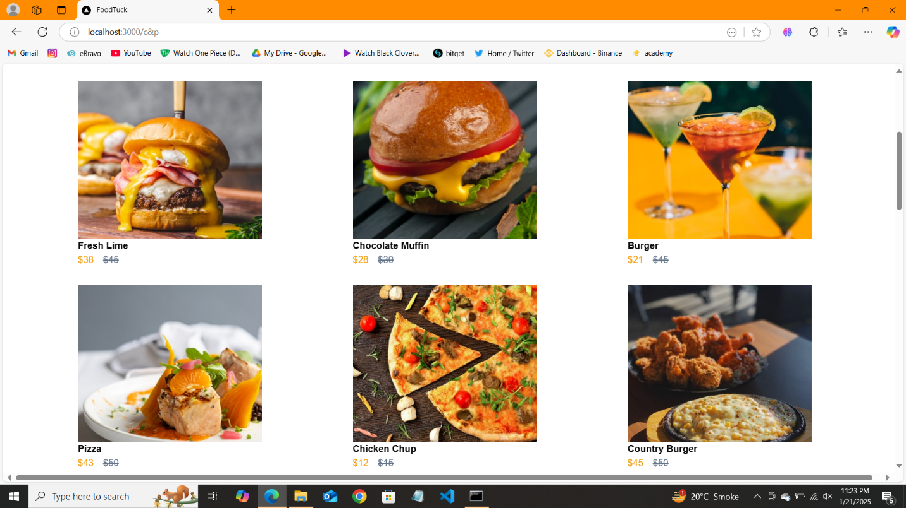

1. Test Case ID : TC002

* Test case Info = Test API Error Handling
* Test Steps = Remove groq query > Refresh Page
* Expected Results = show “Product Not found”
* Actual Results = show “Product Not found”
* Severity Level = Low
* Remarks = Handled Gracefully

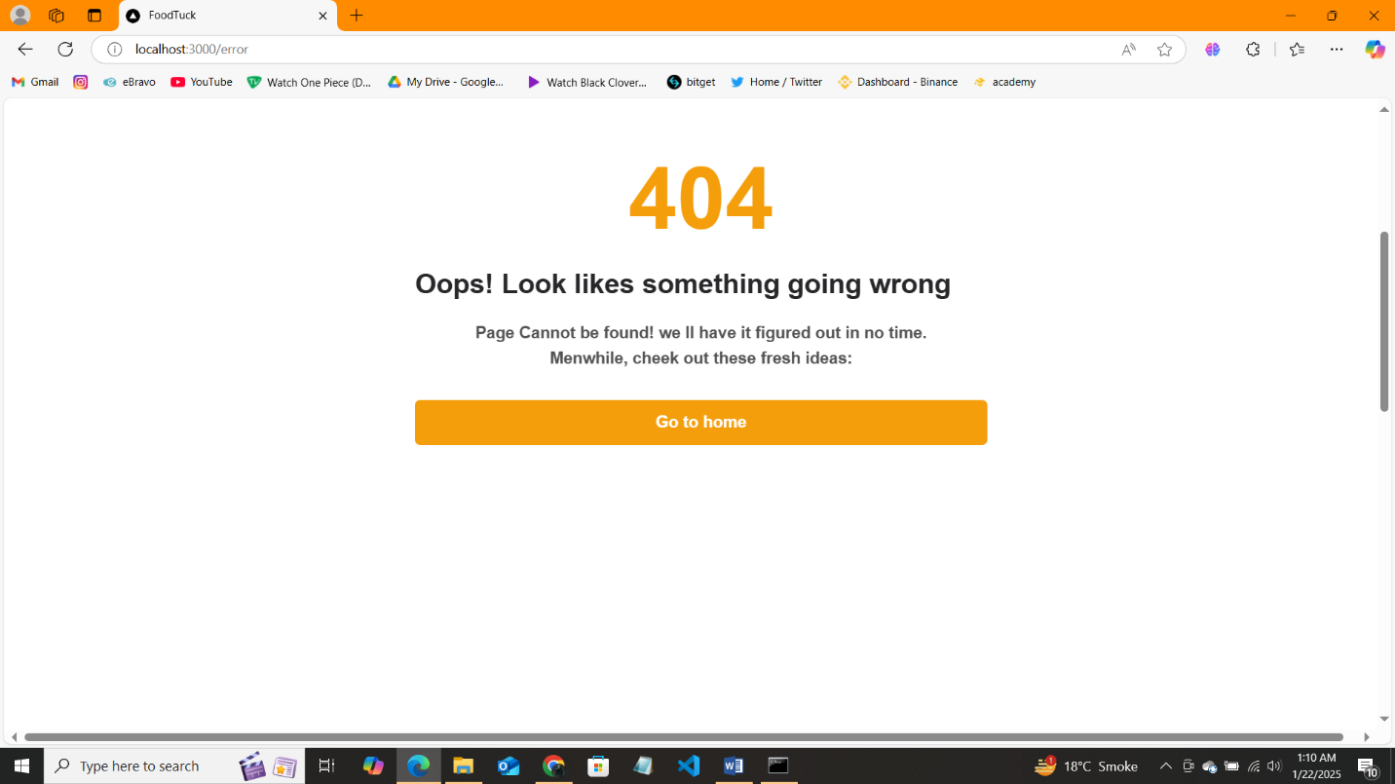

1. Test Case ID : TC003

* Test case Info = Check Cart Functionality
* Test Steps = Add to cart > Nav to cart
* Expected Results = show added Product in cart
* Actual Results = show added Product in cart
* Severity Level = medium
* Remarks = successful

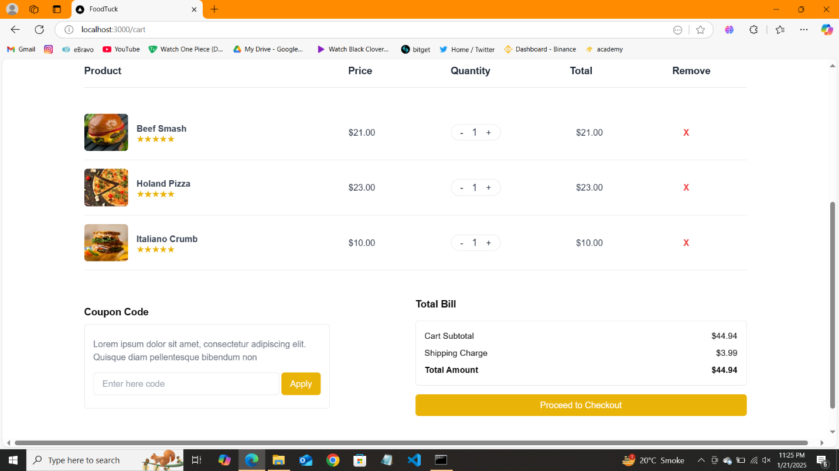

1. Test Case ID : TC004

* Test case Info = Mobile Responsive
* Test Steps = inspect > Tool Bar > Mobile Responsive
* Expected Results = perfect alignment across devices
* Actual Results = perfect alignment across devices
* Severity Level = medium
* Remarks = successful

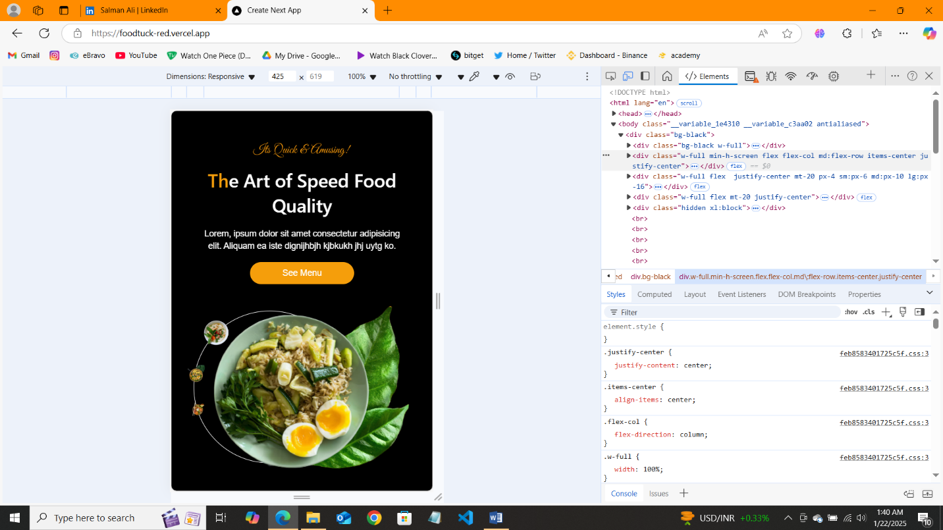

1. Test Case ID : TC005

* Test case Info = Validate Search bar
* Test Steps = search > products
* Expected Results = products displayed
* Actual Results = products displayed
* Severity Level = high
* Remarks = doesn’t show error

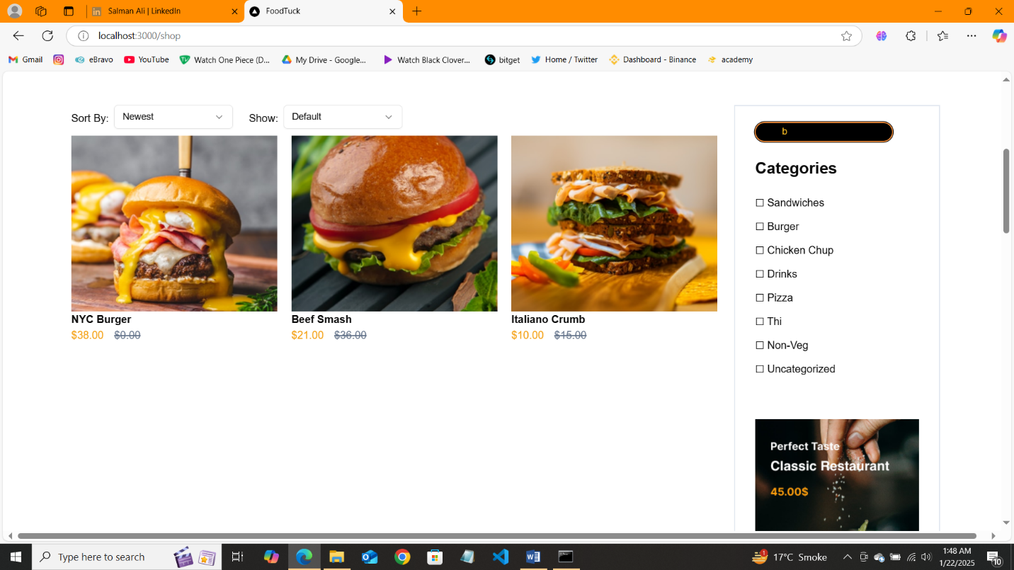

1. Test Case ID : TC006

* Test case Info = Dynamic product
* Test Steps = product list > clicked product page
* Expected Results = product displayed
* Actual Results = product displayed
* Severity Level = low
* Remarks = successful

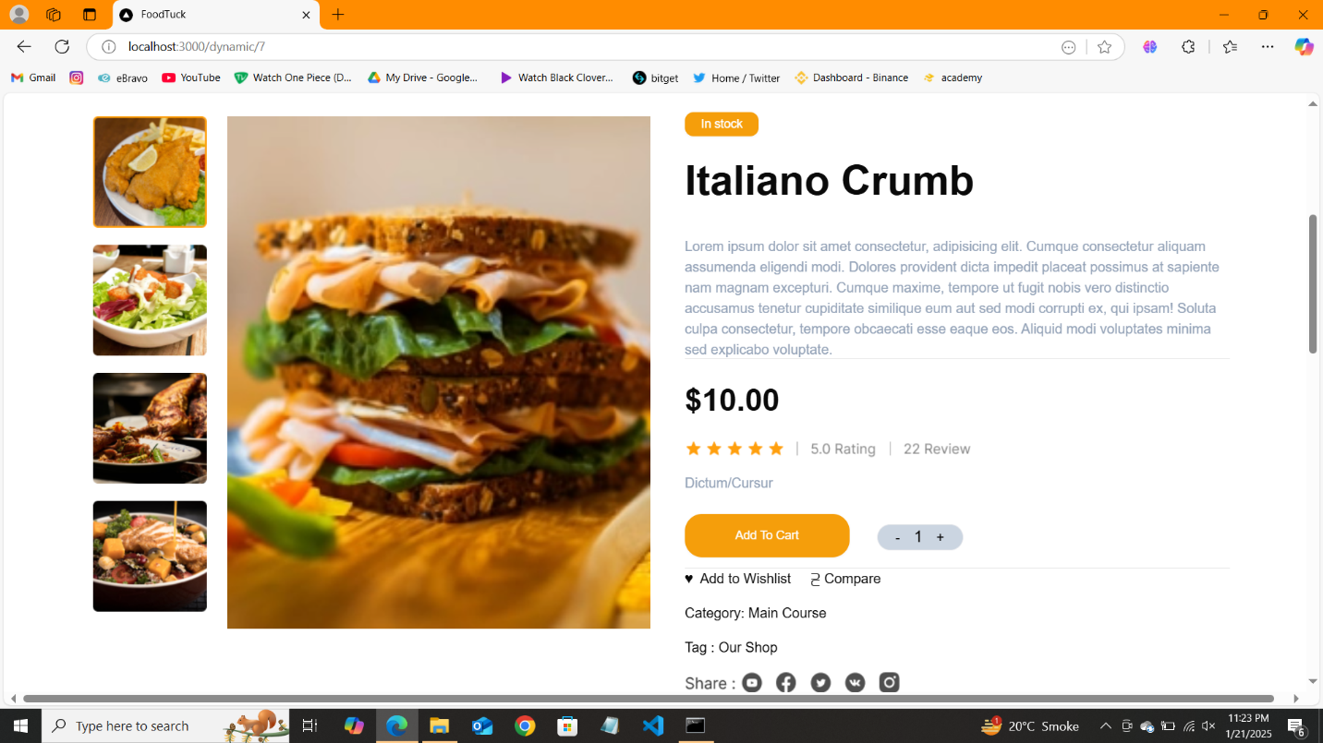

1. Test Case ID : TC007

* Test case Info = Cross Browsing
* Test Steps = open website on different browsers
* Expected Results = Works Fine
* Actual Results = Works Fine
* Severity Level = low
* Remarks = successful

Edge =

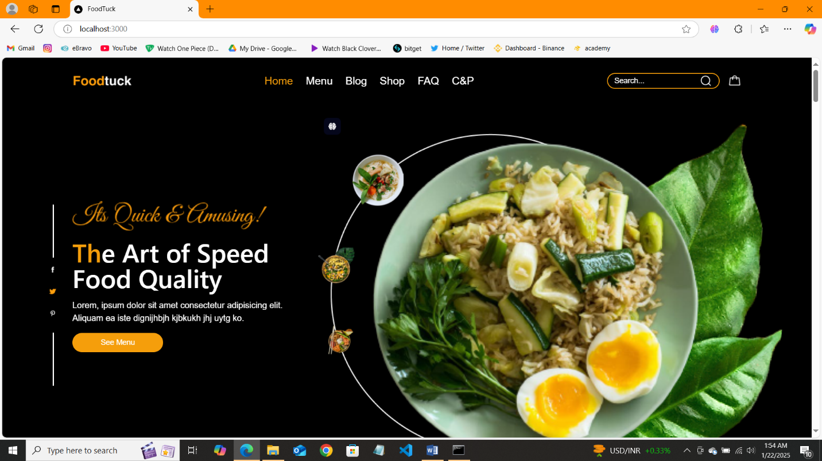

Functional Testing: ✔

Error Handling: ✔

Performance Optimization: ✔

Cross-Browser and Device Testing: ✔

Security Testing: ✔

Documentation: ✔

Final Review: ✔